# Implementation Tests

Contents

Implementation Tests 1

Test Case 1 1

Test Case 1: Table 1

Test Case 1: Screenshots 1

Test Case 1: Evaluation 1

Test Case 2 2

Test Case 2: Table 2

Test Case 2: Screenshots 2

Test Case 2: Evaluation 3

Test Case 3 3

Test Case 3: Table 3

Test Case 3: Screenshots 3

Test Case 3: Evaluation 4

Test Case 4 4

Test Case 4: Table 4

Test Case 4: Screenshots 5

Test Case 4: Evaluation 5

Test Case 5 5

Test Case 5: Table 6

Test Case 5: Screenshots 6

Test Case: Evaluation 7

Test Case 6 7

Test Case 6: Table 7

Test Case 6: Screenshots 7

Test Case 6: Evaluation 8

Test Case 7 8

Test Case 7: Table 8

Test Case 7: Screenshots 9

Test Case 7: Evaluation 9

## Test Case 1

### Test Case 1: Table

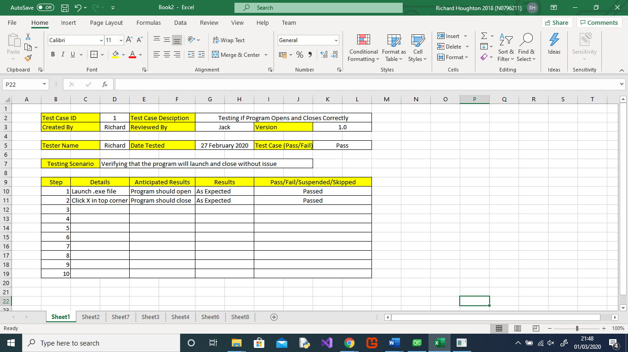

### Test Case 1: Screenshots

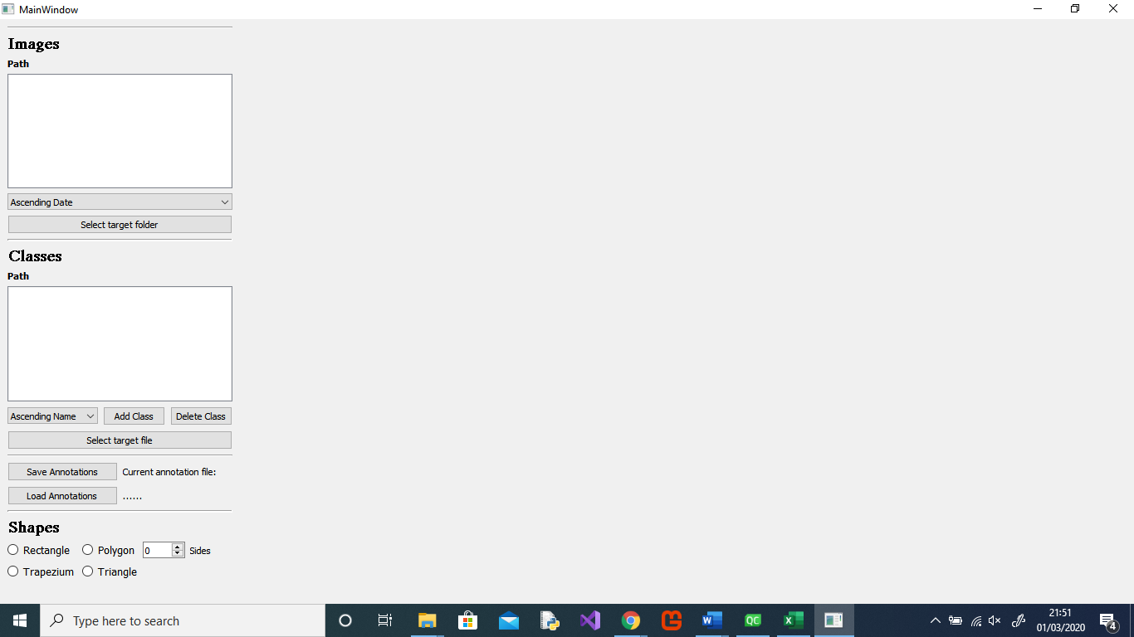

### Test Case 1: Evaluation

The program both launched and closed successfully in a short period of time with no issues as required

## Test Case 2

### Test Case 2: Table

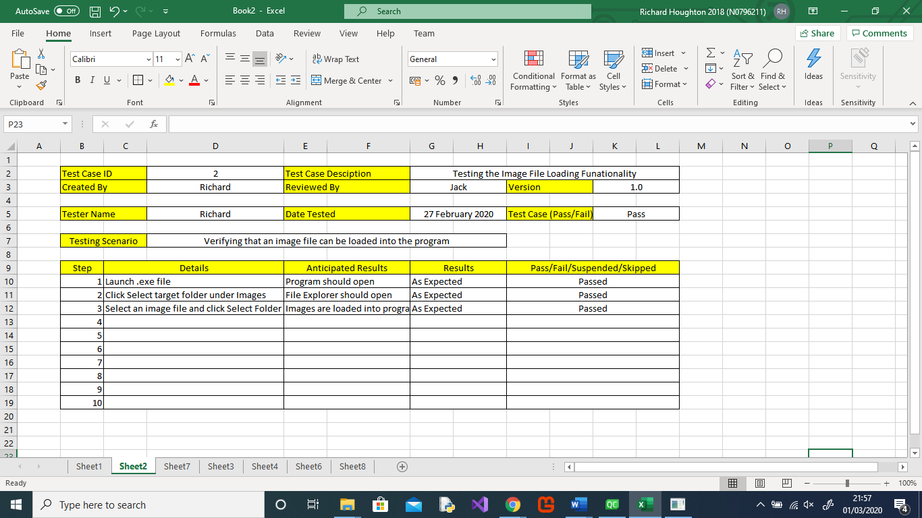

### Test Case 2: Screenshots

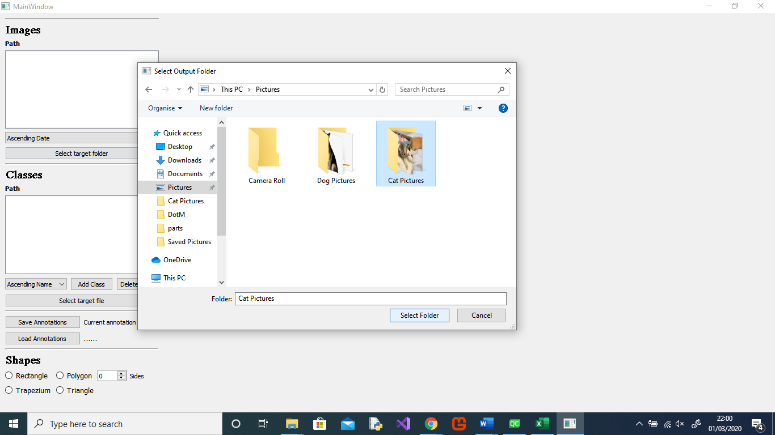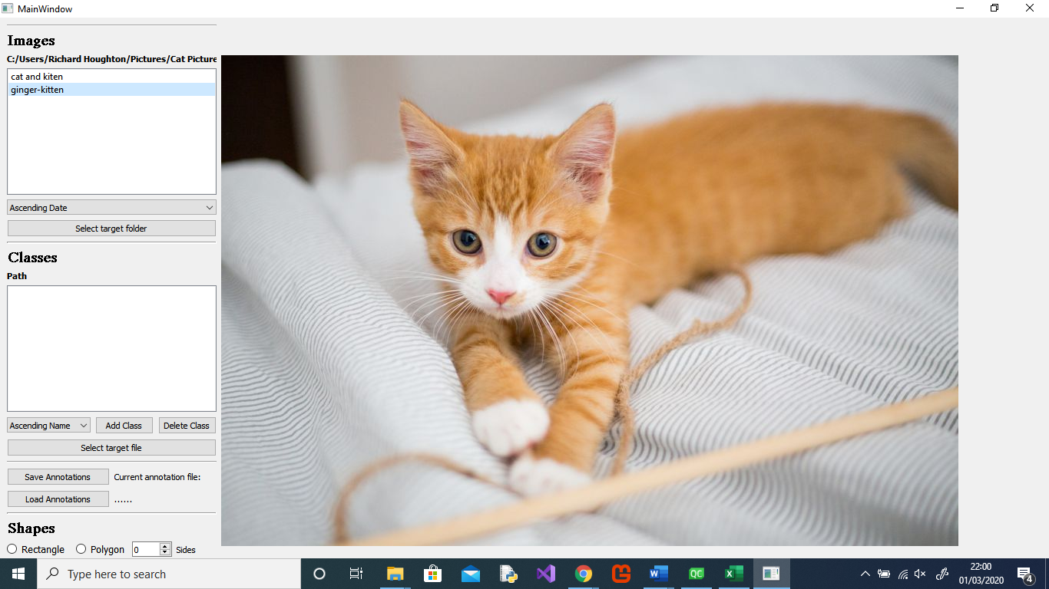

### Test Case 2: Evaluation

File Explorer opened correctly and the images from the selected files were successfully loaded into the project as required.

## Test Case 3

### Test Case 3: Table

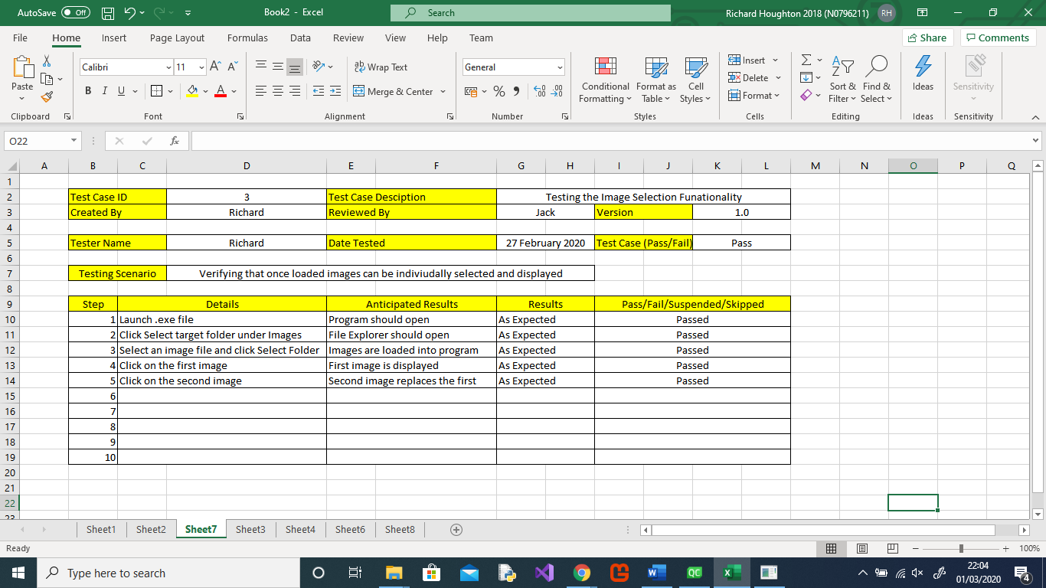

### Test Case 3: Screenshots

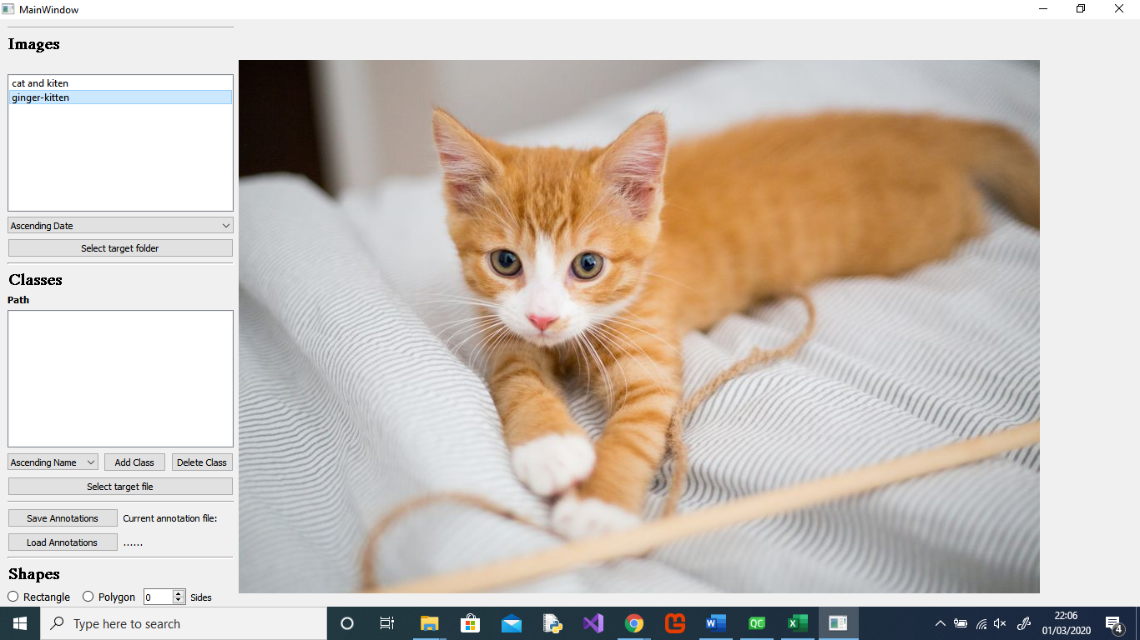

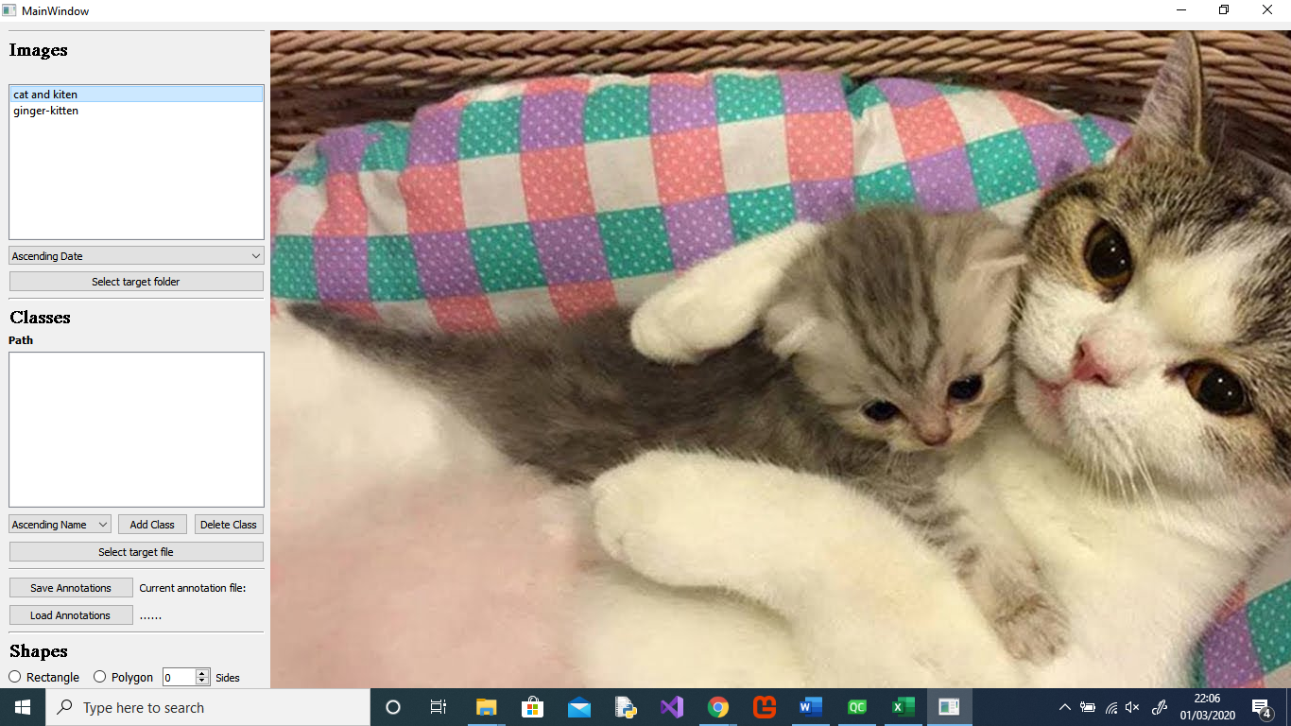

### Test Case 3: Evaluation

When selecting a different image loaded into the program is successfully displayed the selected one and stopped displaying the previous one as required.

## Test Case 4

### Test Case 4: Table

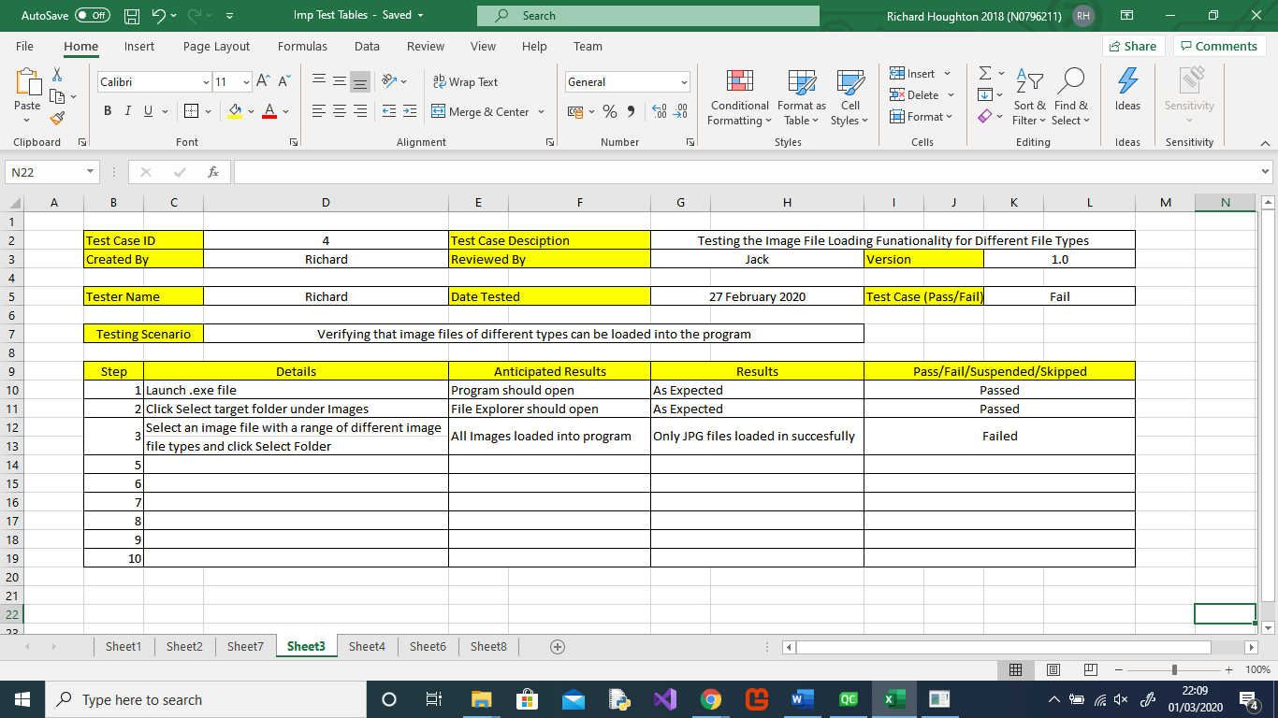

### Test Case 4: Screenshots

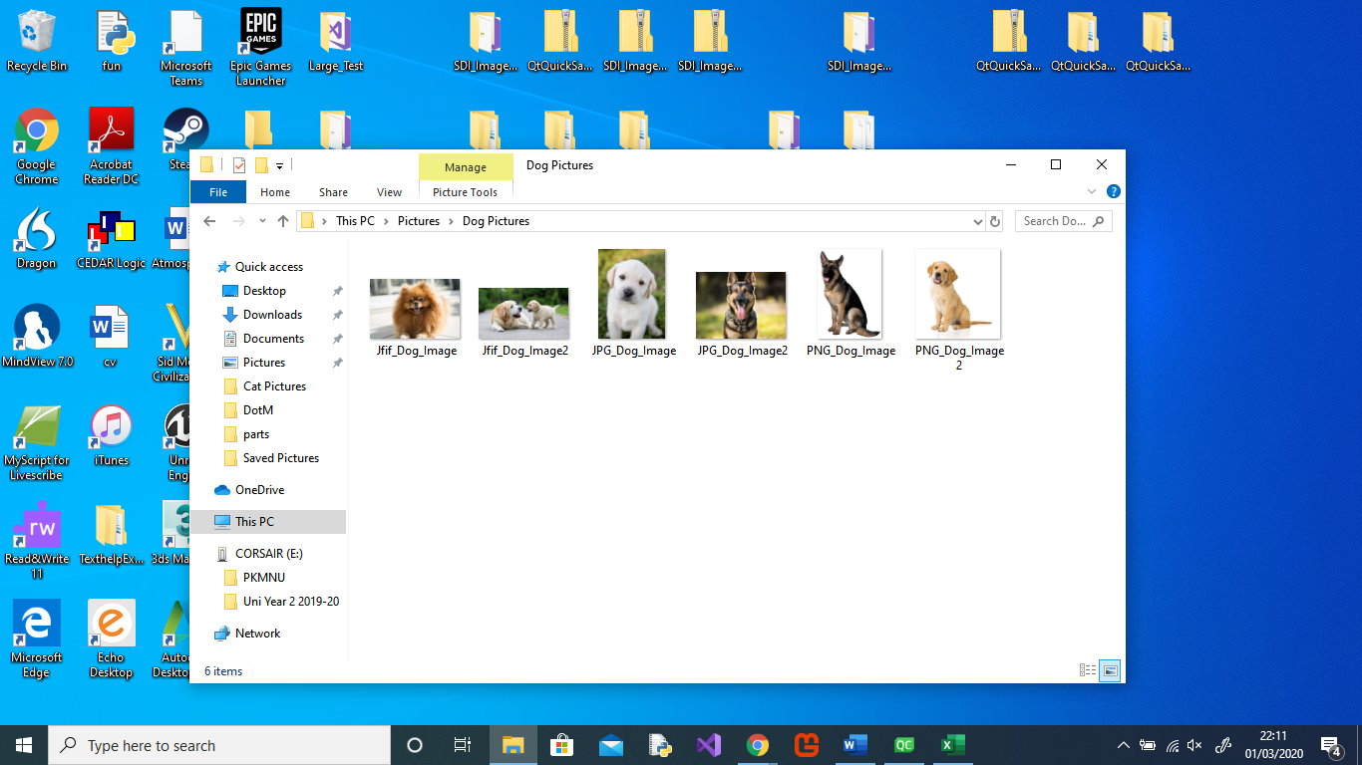

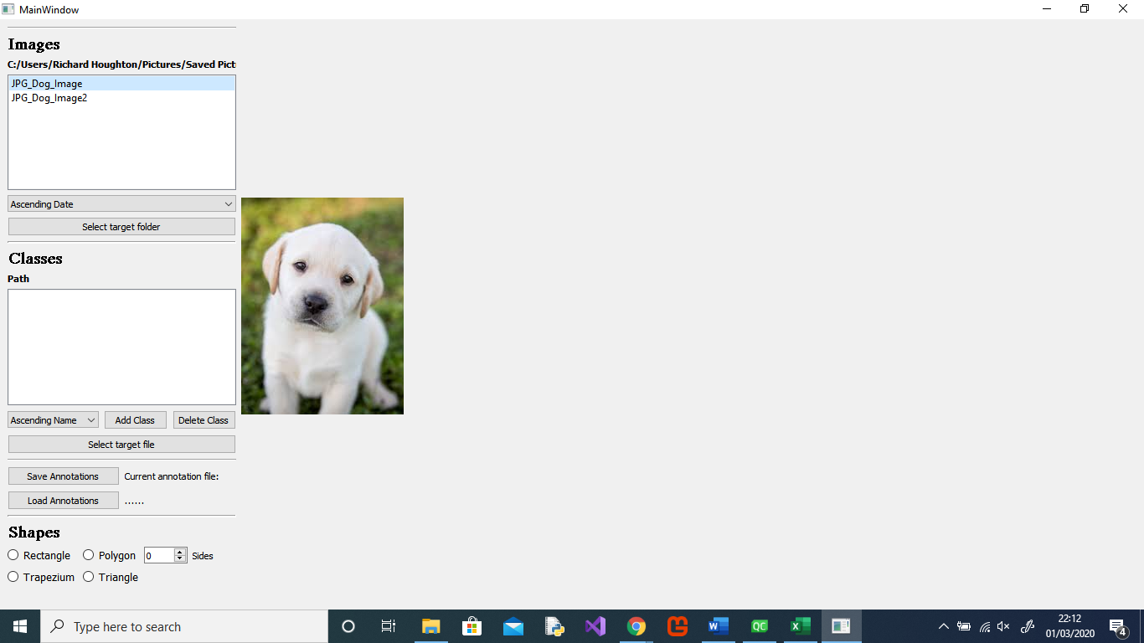

### Test Case 4: Evaluation

Test Case 4 was a failure as the program was only able to load JPG images from the selection within the folder and as such does not meet the requirements of this project.

## Test Case 5

### Test Case 5: Table

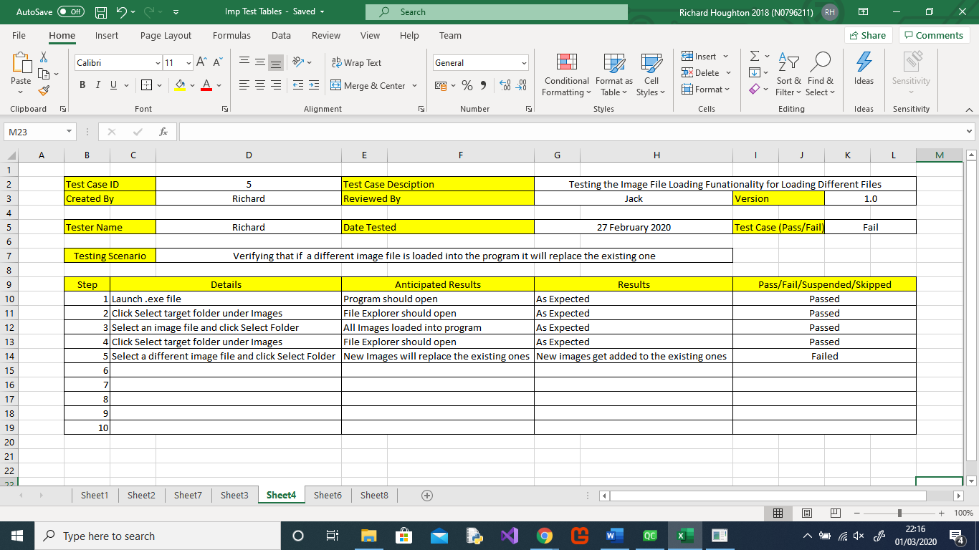

### Test Case 5: Screenshots

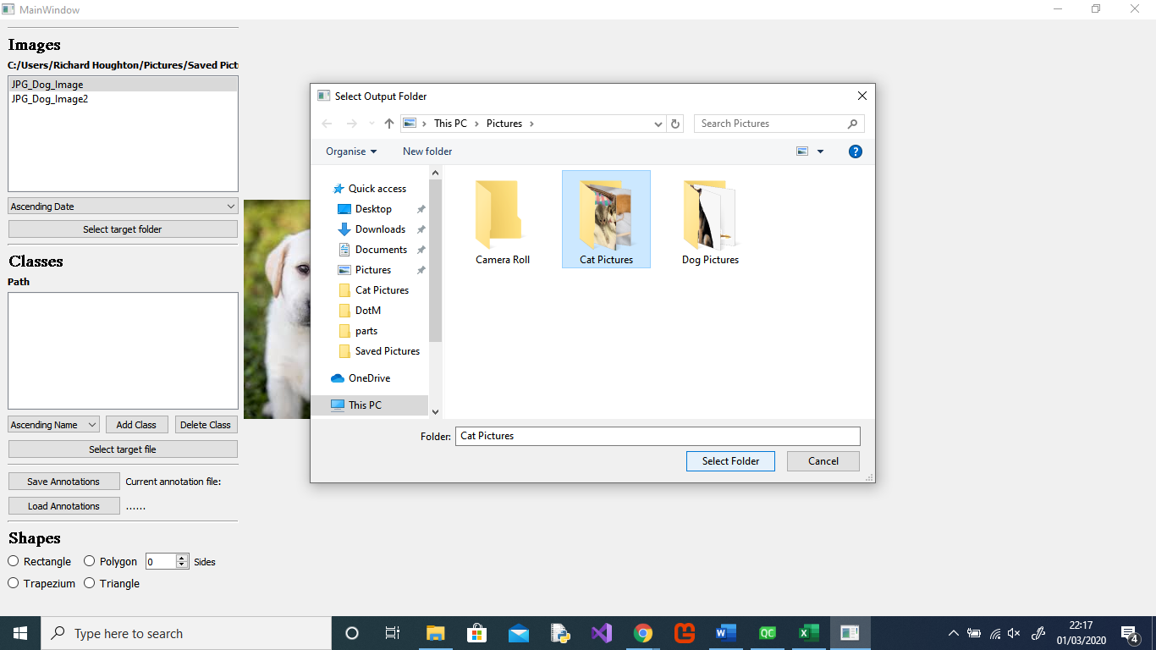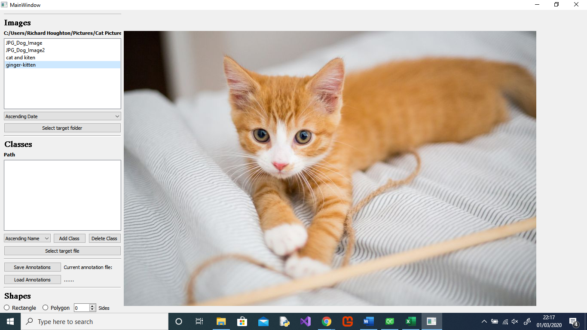

### Test Case: Evaluation

Test Case 5 was a failure as the program loaded the selected files images in with the existing ones rather than replacing them and as such does not meet the requirements of this project.

## Test Case 6

### Test Case 6: Table

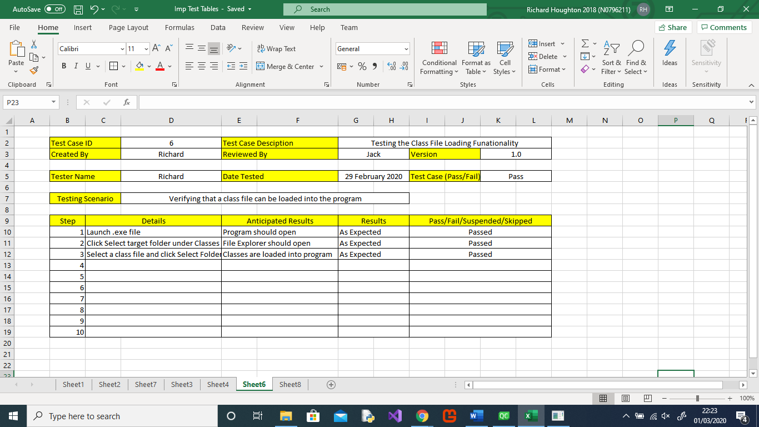

### Test Case 6: Screenshots

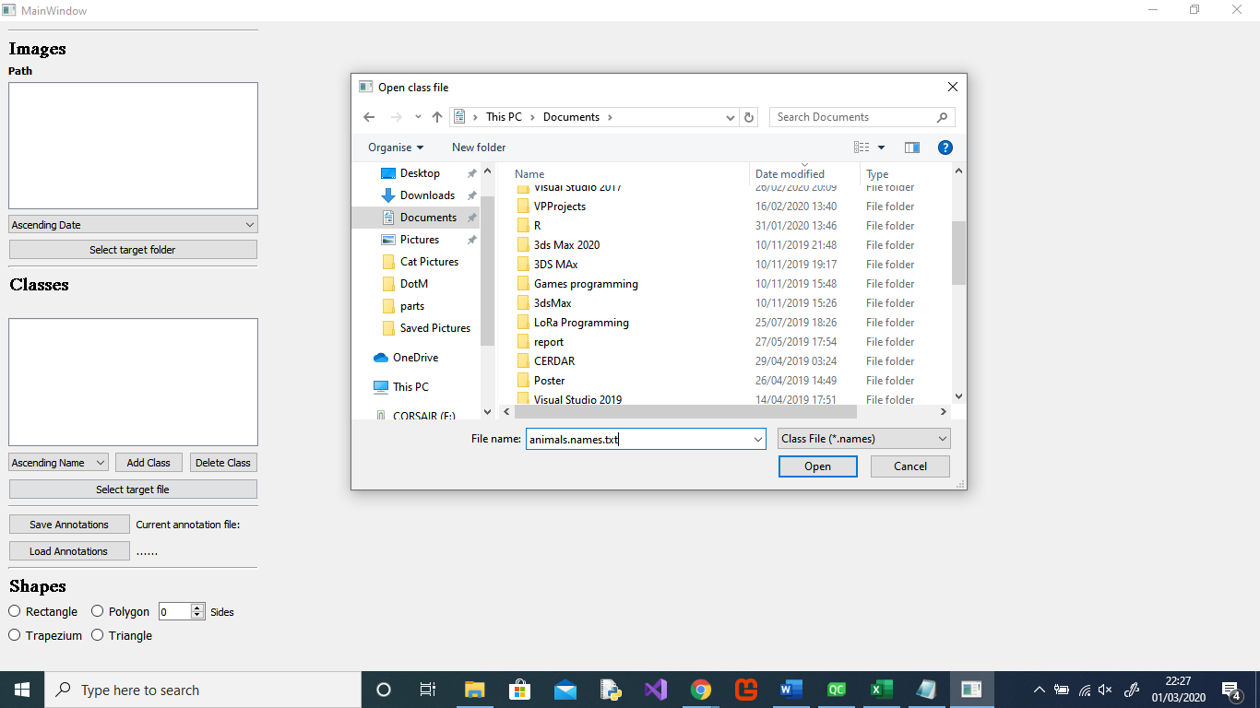

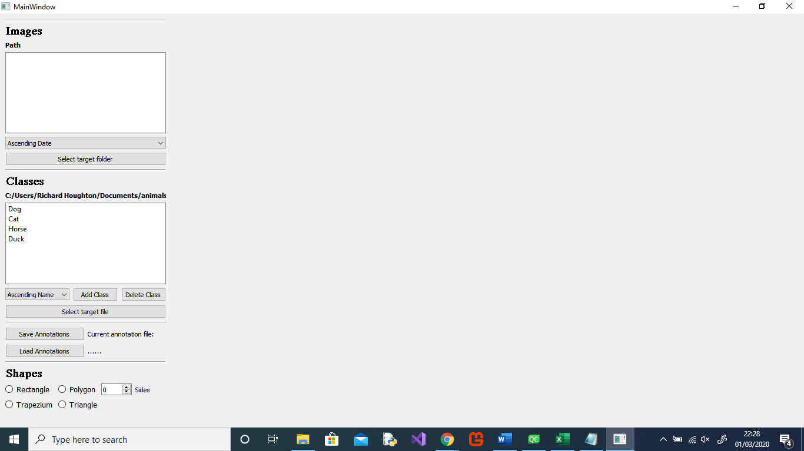

### Test Case 6: Evaluation

File Explorer opened correctly and the classes from the selected files were successfully loaded into the project as required.

## Test Case 7

### Test Case 7: Table

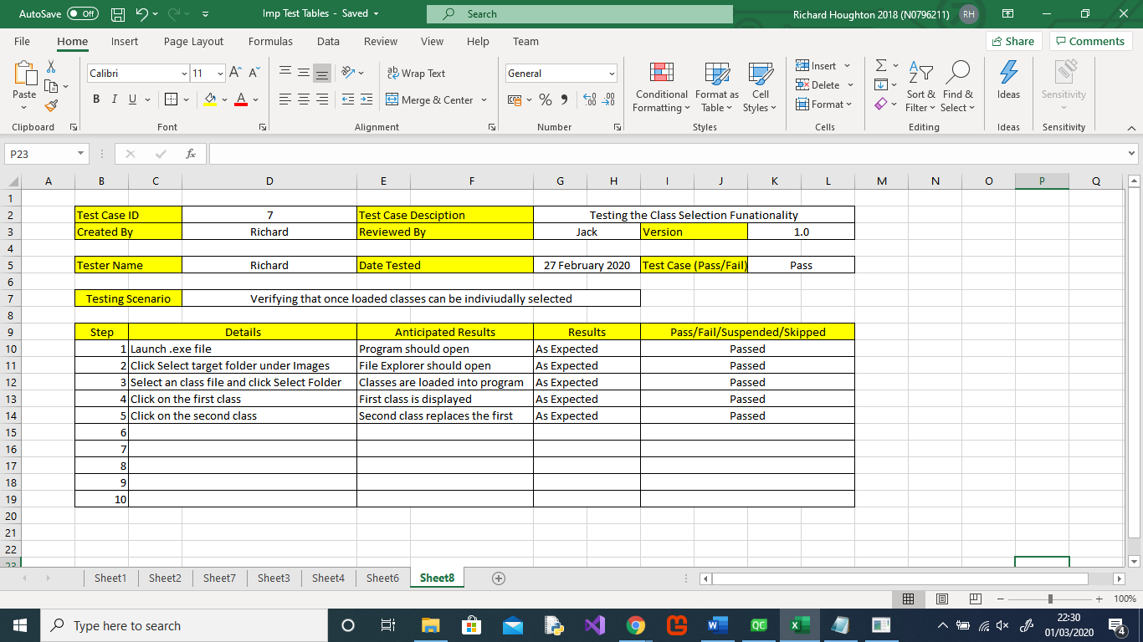

### Test Case 7: Screenshots

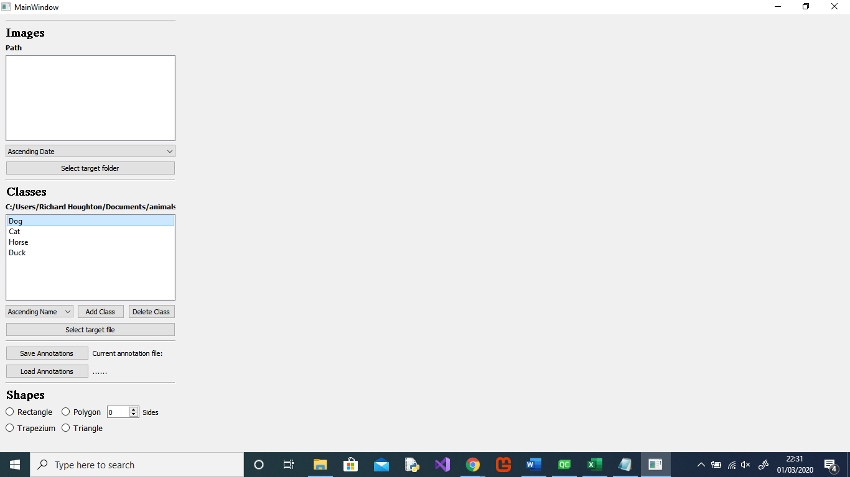

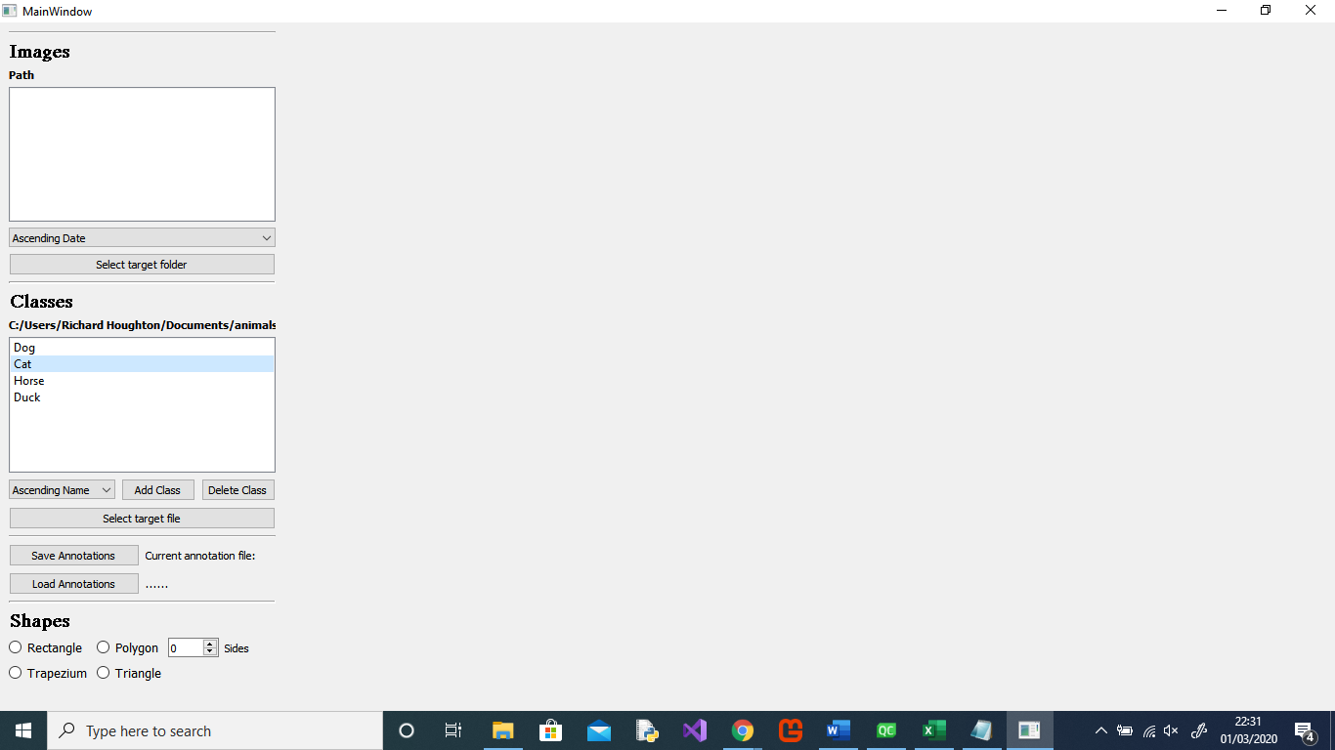

### Test Case 7: Evaluation

When selecting a new class, the previous one is deselected as required.